**WA State Elementary Chess Championships**

Apr 12, 2014

Smith Cove Cruise Terminal

Pier 91, Magnolia WA

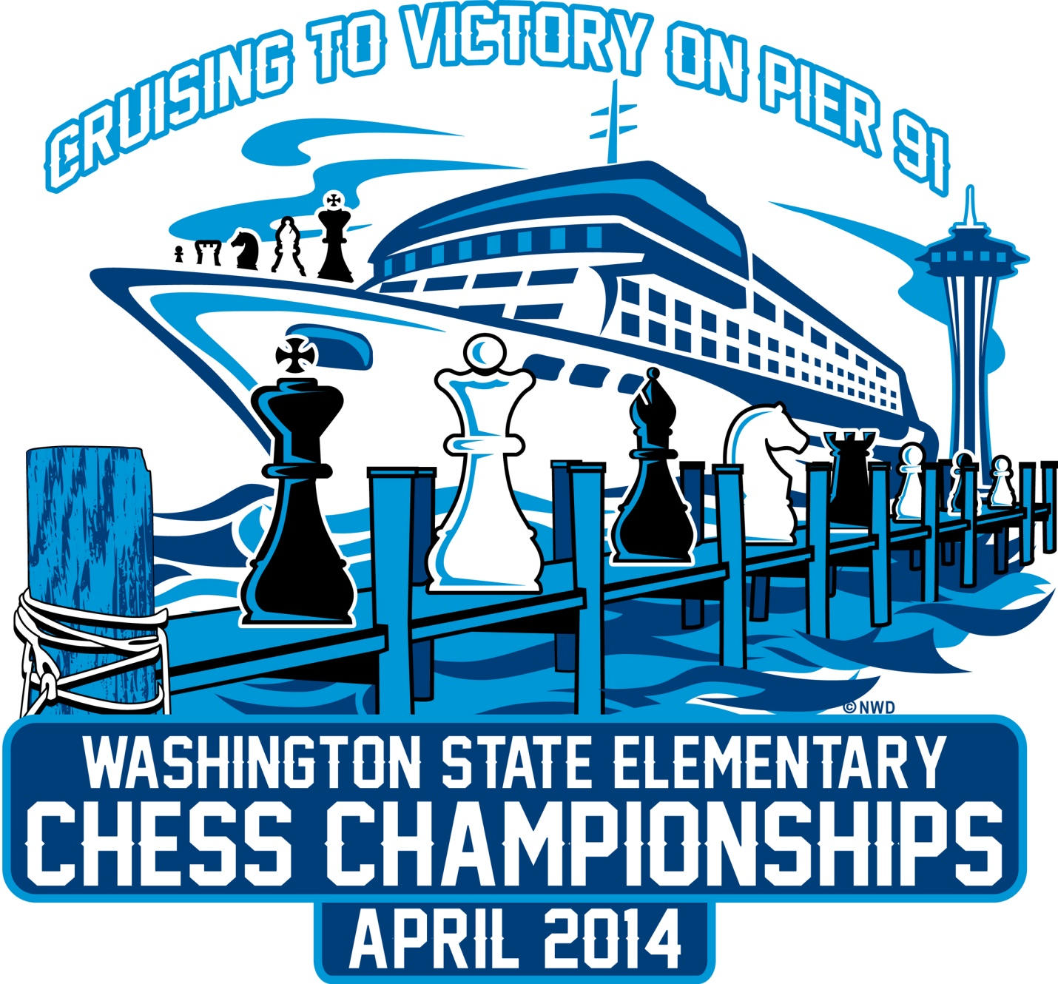

Our tournament this year will have beautiful water views from a cruise ship terminal building in Magnolia, just north of the Space Needle! We have 145,000 square feet of space, and spacious outside decks to enjoy sweeping views of the Puget Sound and downtown Seattle. No cruise ships in port on our weekend.

See our website at <http://wsecc2014.com>, or like our Facebook page at 2014 Washington State Elementary Chess Championships.

Sections:

Kindergarten

1st Grade

2nd Grade

3rd Grade

4th Grade

5th Grade

6th Grade

I Love Chess Too K-3

I Love Chess Too 4-6

I Love Chess Too 7-Adult

Entry Fees:

$45 by Feb 1st

$55 by Mar 1st

$65 by Apr 1st

Registration closes Apr 1st.

Registration:

Register online at <http://nwchess.com/OnlineRegistration>. Qualification needed (scoring 3.0 or higher in any qualifying tournament) to play in the seven grade sections, but OK to register before you have qualified – we will move you between I Love Chess Too and the appropriate grade section. No qualification needed for I Love Chess Too sections.

Chess Club Directors and Coaches may order lunches or team seats by selecting the Directors and Coaches non-playing section when registering.

Schedule:

7:00am – Pairings for Round 1 posted.

7:00am to 8:50am: Check in by picking up your registration envelope. Any players whose envelopes are not picked up by 8:50am will receive 0 point byes and will be manually replaced in the pairings.

9:00am – All players in their seats, instructions to players.

9:15am - Round 1

10:45am – Round 2

11:00am to 12:45pm – Lunch

12:45pm – Round 3

2:00pm – Round 4 (may be pulled earlier if possible)

3:15pm – Round 5 (may be pulled earlier if possible)

4:45pm – Trophy presentation

6:00pm – Tournament complete

Parking:

Parking is $10 per car. There is a parking lot north of Pier 91with room for 1600 cars, with free shuttle service to take you to the playing site. There are no in and out privileges. Carpooling, arranging to be dropped off, or taking a shuttle from your hotel may save you money on parking. It is recommended you drop off at the playing site first, and then only the driver parks the car to lessen the load on the shuttles.

**From I-5:** take Exit 167 / Mercer Street

* Stay on Mercer over the New Mercer Lid
* Turn right onto Denny
* Slight right onto Western
* Western merges into Elliot Ave. Continue north for about a mile.
* Follow signs to Magnolia Bridge
* Turn right at 14th Ave W.
* Keep right and follow ramp which goes to Magnolia Bridge (West Garfield St.)
* Exit right off bridge- Following signs to "Smith Cove Park" and Cruise Terminal
* Turn right at bottom of ramp and follow signs for Event Parking and Cruise Terminal

Food: There is no kitchen on site to prepare the food, so all food is being prepared off site and brought in, so pre-ordering is REQUIRED so we can plan to have enough. Deadline to pre-order lunch is Apr 1st. Prices include sales tax:

$6.00   Breakfast coffee or juice, muffin, banana

$8.00   Hotdog with chips, drink, cookie

$8.00   Pizza 1 slice (Cheese, Pepperoni, Hawaiian, Combo) with chips, drink, cookie

$10.00   Pizza 2 slices (Cheese, Pepperoni, Hawaiian, Combo) with chips, drink, cookie

$10.00   Caesar Salad with breadsticks, drink, fruit

$10.00   Chef Salad with breadsticks, drink, fruit

$12.00   Sandwich (turkey, ham and cheese, roast beef) with chips, drink, cookie

If you have food allergies, or if you prefer to bring your own lunch, this site does allow you to bring your own food. Snacks, drinks, and dinner Sat evening will also be available.

Team tables:

$5 per seat (with part of a table) or $30 per rectangular 6 foot table (with 6 seats). There is no free seating at this event, if you don’t select a team seat, you will be sitting on the floor or need to bring you own chair. Team seats must be pre-ordered before Apr 1st. Teams will be automatically grouped together by school.

Commemorative boards:

$20 each - includes vinyl chess board with 2014 logo, plastic pieces, and zippered bag. Pick these up at the end of the tournament at the check in tables.

Internet/Electrical power:

Internet access at this site is very expensive; it is recommended you plan to use your cell phone mobile hot spot if you can. We are looking for some solutions to internet access, check back later. Some tables will be setup with electrical power where you can recharge your electronics.

Layout:

Upper floor holds the team table area and the stage with the trophies. There are large windows on the south end, and wide outside covered decks to view the water and Seattle cityscape.

Lower floor holds the playing area and Tournament Director area.

Lobby area holds the check in tables, the grab-and-go trophies, and the vendors.

Stairs with escalators and elevators are located at both the front and back of the building. Bath rooms are located on both floors.

Pairings and Standings:

Pairings and standings will be posted on both floors near the bathrooms, and can be viewed online at <http://nwchess.com/OnlineRegistration>. Find the tournament WA State Elementary Chess Championships, and then click the Standings and Pairings buttons.

Trophies:

On stage:

Top 25 places for each grade K-6

Top 20 Team trophies in 1-3 and 4-6

Top 3 Team trophies in Kindergarten

Pick up and leave early at the check in tables:

3.0 and 3.5 trophies not in the top 25.

Medals for all those scoring 2.5 or less

Top 10 places for I Love Chess Too K-3, 4-6, and 7-Adult.

Bughouse Tournament is Friday Apr 11th at the Smith Cove Site:

See the Bughouse flyer at <http://nwchess.com/OnlineRegistration> for details.

Volunteers:

Many volunteers needed for set up, take down, greeters, lunch servers, judges, scorers, pairings posters, trophy distribution, etc. Sign up to volunteer at [www.SignUpGenius.com/go/70A084FAFAB2E5-volunteers](http://www.SignUpGenius.com/go/70A084FAFAB2E5-volunteers).

Hotels (sorted by closest distance to playing site):

Hilton Homewood Suites, 1.7 miles, $138/night.

206 Western Ave W, Seattle WA. 206-281-9393

Fully equipped kitchen, breakfast, in-suite internet, underground parking.

Reserve before Mar 7th

Sheraton Four Points, 2.2 miles, $105/night

301 Roy Street, Seattle WA. 206-282-2600  
  
Hampton Inn & Suites, 2.2 miles, $138/night

700 5th Ave N, Seattle WA. 206-441-6041

Breakfast included

Crown Plaza, 3.4 miles, $149/night.

1113 6th Avenue, Seattle WA. 1-888-233-9527

Free WiFi in room. Parking is $18 per night  
 Reserve before Mar 11th.

Marco Polo Motel 4.5 miles, $65/single queen, $75 for two queens, and 10% discount for the first 10 rooms booked mentioning our event.

4114 Aurora Ace NE, Seattle WA. 206-633-4090

Free parking, wireless internet, refrigerator, and microwave.

Hotel Nexus, 7.1miles, $95/night

2140 North Northgate Way, Seattle WA. 1-800-435-0754

Breakfast included, free shuttle to Pier 91

Reserve by calling (rate not available online) before Mar 17th.

Vendors on site:

Chess4Life

Orlov Chess Academy

NW Designs T-shirts

University Book Store

Dill Books

Pico Dragons

Grandpa Beck’s Games

Sponsors:

Chessmates Foundation

Beacon Law Advisors, PLLC

Sponsorships:

Sponsorships are being sought. The Chessmates Foundation is a 501c(3) tax deductable organization:

A $500 donation will sponsor 10 chess kids on scholarship, and we will put your name in the brochure.

Or, a $500 donation will get your logo on one corner of the commemorative chess boards – your logo will be visible for years as the chess boards are sold to players and any leftovers are used in tournaments for a long time. Only 2 corners are left (our tournament logo takes one square), first come, first served.

A $750 donation will sponsor 15 chess kids on scholarship, and you get your name in the brochure, and a banner in the team area.

A $1000 donation will sponsor 20 kids on scholarship, and you get your name in the brochure, 3 banners in the team area, and your name printed on the T-shirts.

A $3000 donation will sponsor 60 kids and make you the title sponsor, with name on the banner above the trophies and name engraved on the trophies.

Directors:

David Hendricks, Tournament Director, WCF Scholastic Director

Questions? [DavidCHendricks@comcast.net](mailto:DavidCHendricks@comcast.net) (425) 868-3881 or (425) 269-7949

Ben Radin, President, Chessmates Foundation

Duane Polich, Vice President of Chessmates Foundation and WCF

Georgi Orlov, Executive Director of Chessmates Foundation

Mark Knudsen, Fifty Best, Event Planner